Create a React Application named “ticketbookingapp” where the guest user can browse the page where the flight details are displayed whereas the logged in user only can book tickets.

The Login and Logout buttons should accordingly display different pages. Once the user is logged in the User page should be displayed. When the user clicks on Logout, the Guest page should be displayed.

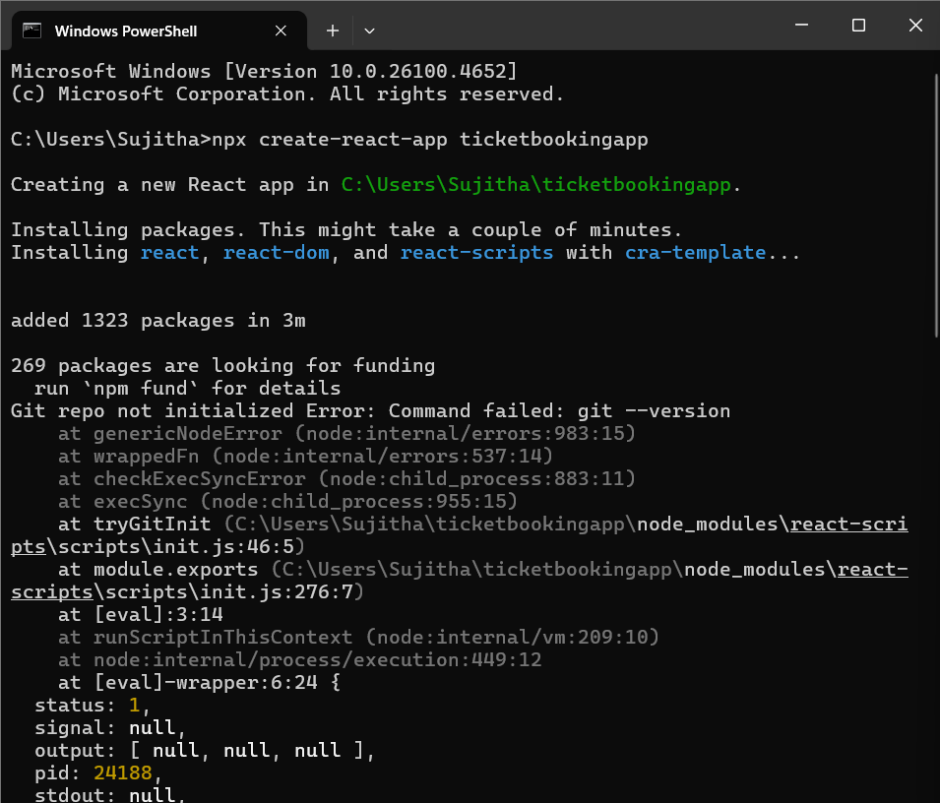

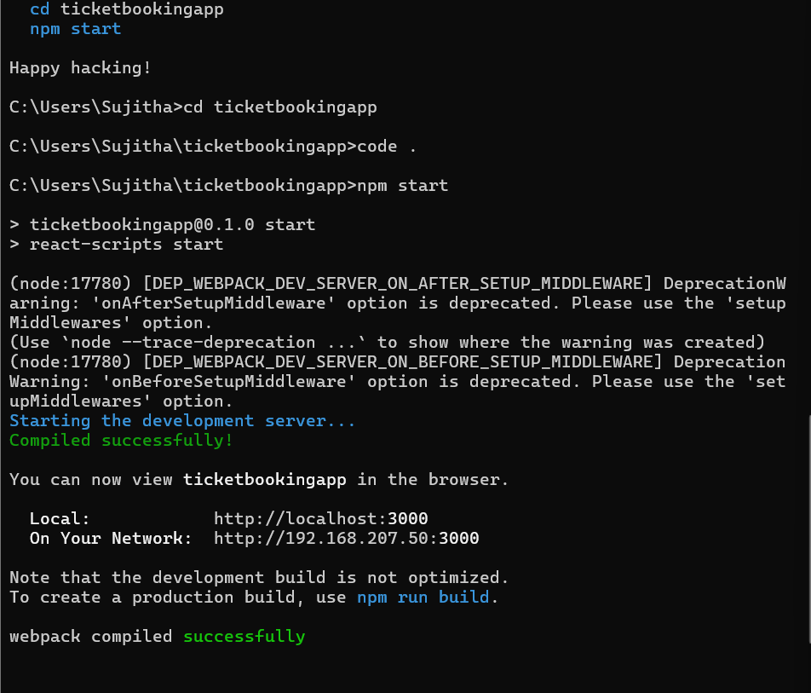

**App.js**

// src/App.js

import { useState } from 'react';

import Header from './Components/Header';

import GuestPage from './Pages/GuestPage';

import UserPage from './Pages/UserPage';

function App() {

  const [isLoggedIn, setIsLoggedIn] = useState(false);

  const handleLoginToggle = () => {

    setIsLoggedIn(prev => !prev);

  };

  let content;

  if (isLoggedIn) {

    content = <UserPage />;

  } else {

    content = <GuestPage />;

  }

  return (

    <div>

      <Header isLoggedIn={isLoggedIn} onLoginToggle={handleLoginToggle} />

      {content}

    </div>

  );

}

export default App;

**GuestPage.js**

function GuestPage() {

  return (

    <div>

      <h2>Welcome, Guest!</h2>

      <p>You can browse the flight details here.</p>

    </div>

  );

}

export default GuestPage;

**UserPage.js**

function UserPage() {

  return (

    <div>

      <h2>Welcome, User!</h2>

      <p>You can book tickets from this page.</p>

    </div>

  );

}

export default UserPage;

**Header.js**

// src/Components/Header.js

function Header({ isLoggedIn, onLoginToggle }) {

  return (

    <header>

      <h1>Flight Ticket Booking App</h1>

      <button onClick={onLoginToggle}>

        {isLoggedIn ? 'Logout' : 'Login'}

      </button>

    </header>

  );

}

export default Header;

**Output**

